**Arduino-Based Weather Monitoring Station with a Data Logging System**

|  |  |  |  |
| --- | --- | --- | --- |
| **ABDUL-NASIR, Mohammed Suraju** *Dept. of Telecommunication Engineering* *K.N.U.S.T* 3056420 20745096 | **AMOAKO, David Kofi** *Dept. of Telecommunication Engineering* *K.N.U.S.T* 3059720 20720713 | **BAIDOO, Crenshaw** *Dept. of Telecommunication Engineering* *K.N.U.S.T* 3062820 20757338 | **EZEKIEL, Shallom** *Dept. of Telecommunication Engineering* *K.N.U.S.T* 3065920 20778585 |

|  |  |  |
| --- | --- | --- |
| **LETSU, Charles** *Dept. of Telecommunication Engineering* *K.N.U.S.T* 3069120 20784339 | **OSEI, Matilda** *Dept. of Telecommunication Engineering* *K.N.U.S.T* 3072720 20780961 | **NSIAH, Aninkurah Nathanael** **Joel** *Dept. of Telecommunication Engineering* *K.N.U.S.T* 3075720 20764648 |

**ABSTRACT**

Arduino is an open-source platform that enables us to build electronics projects. It consists of a physical Programmable Circuit Board (PCB) and an Integrated Development Environment (IDE). We used Arduino to develop a weather monitoring system based on temperature and humidity, and rainfall variables obtained from a DHT11 sensor and a raindrop sensor respectively. This data obtain is then logged using the MicroSD card module.

The weather data is viewed in real-time through a 20x4 Liquid Crystal Display (LCD). The system, when tested,

it was able to measure the temperature, humidity and rainfall, giving the reading at interval of five seconds. It was observed that the average temperature from results obtained 25.120C. Also, the average relative humidity obtained was 80.41% on 25th March, 2023.

**1. INTRODUCTION**

Weather is the state of the atmosphere and can be determined by several variables including pressure, wind, precipitation, solar radiation, temperature and humidity and so on. A weather station is a facility located either on land or sea consisting of instruments and equipment which can be used to measure atmospheric conditions so as to provide weather forecasts information and to study the weather

Relative Humidity (RH) is the ratio of the current absolute humidity to the highest possible absolute humidity (which depends on the current air temperature). The air’s ability to hold water increases with an increase in temperature. At 100% RH, the air is totally saturated with water vapor and cannot hold any more, creating the possibility of rain. The RH near the ground is often lesser than higher up the atmosphere where the clouds are forming.

**2. COMPONENTS USED FOR THE DESIGN**

Table 1 below shows the components used for the construction of an Arduino-based Temperature and Humidity Monitoring System. The specific properties of each of the components used in the design are also detailed in the table.

Table 1: List of Components used for the design

|  |  |  |
| --- | --- | --- |
| S/N | Component | Properties |
| 1. | Humidity and Temperature Sensor | DHT11 |
| 2. | Microcontroller | Arduino UNO (Rev3) |
| 3. | Resistor, R1 | tolerance ±5%; resistance 220Ω |
| 4. | Real-time Clock | DS3231 RTC |
| 5. | Monitor | Liquid Crystal Display (LCD) - characters 20x4, with I2C module |
| 6. | Jumpers | male – male, male – female, female – female |
| 7. | Raindrop sensor | YL-83 rain sensor and rain sensor control board |
| 8. | SD card module | MicroSD card module, MicroSD card with its card reader |
| 9. | Breadboard | Full breadboard |
| 10. | L.E.D | Yellow L.E.D |

**3**. **METHODOLOGY AND SYSTEM DESIGN**

The Arduino Uno Microcontroller Board was used as the main hardware component, while the Arduino IDE was used in writing the instruction codes (known as firmware) which was uploaded into the microcontroller.

Fig 3 shows the circuit diagram used to design the Weather Monitoring System. Fig 4 highlights the implementation of the circuit diagram using the selected components. The connections between components are also shown.

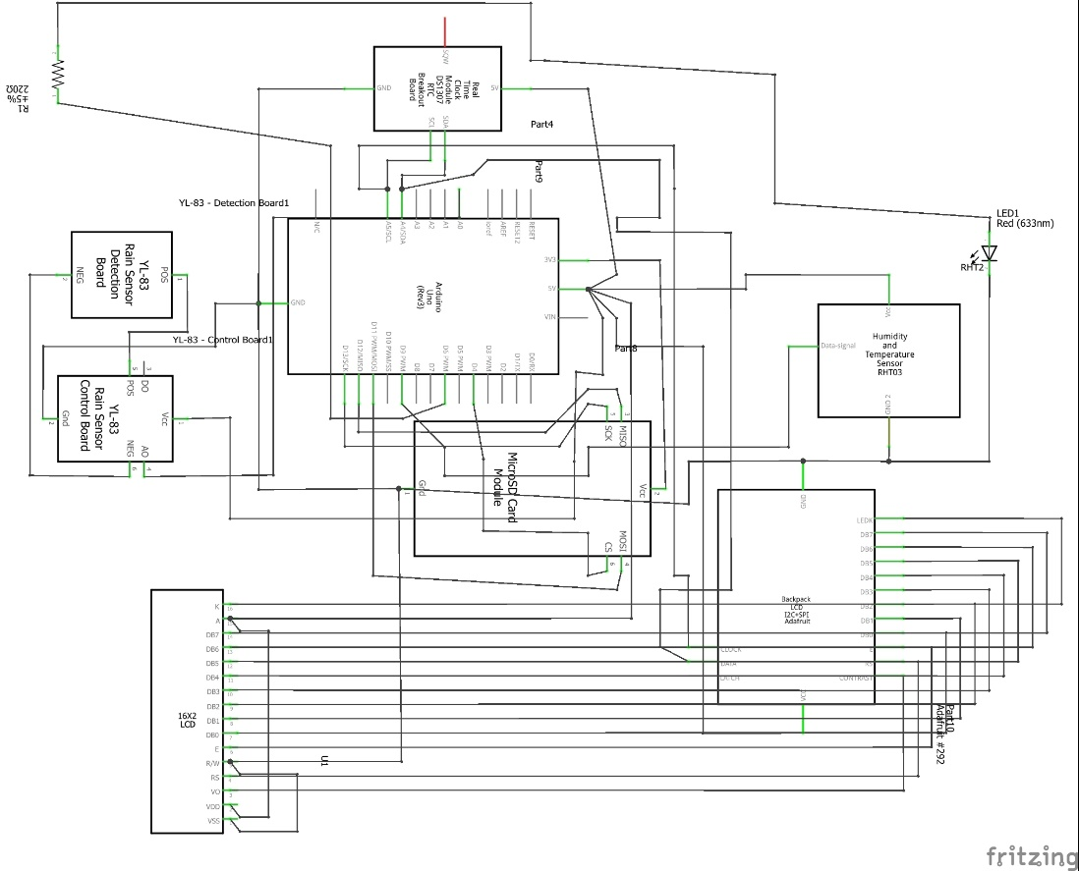

**Fig 3: Schematic for Arduino-based Weather Monitoring Station with a Data Logging System**

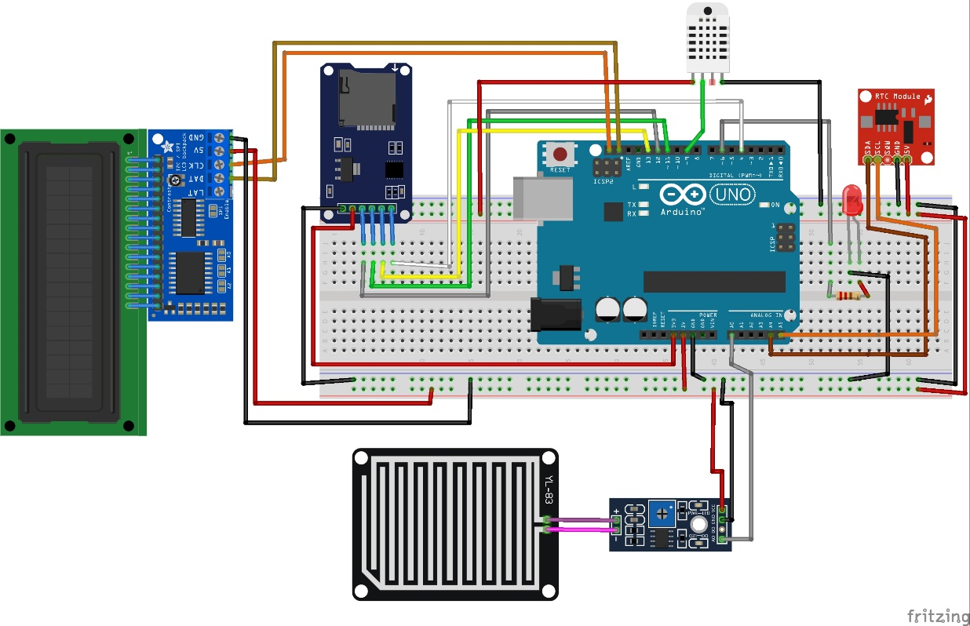

**Fig 4: Connections for the** **Arduino-based Weather Monitoring Station with a Data Logging System**